SWT 22022 – Practical for Internet Application Development
Department of Information and Communication Technology
Faculty of Technology
Lab sheet :04
Reg. Number: SEU/IS/20/ICT/084
Academic Year :2020/2021
Date: 2024.09.06
Practical No :04

Title: Introduction to JavaScript.
Aims:
• Running JavaScript in different ways
• Getting knowledge about data types in JavaScript
• Getting understand about objects and functions in JavaScript
• Getting familiar with event handling in JavaScript
Tasks:
• JavaScript placement
• Variable & Data Types
• Introduction to Objects and Functions in JavaScript.
• Exploring Event Handling in JavaScript

Activities :

- JavaScript Placement in HTML file
- Script in <head> section

<head>
<title>JavaScript Placement in HTML file</title>
<script>
function sayHello() {
alert("Hello World")
}
</script>
</head>

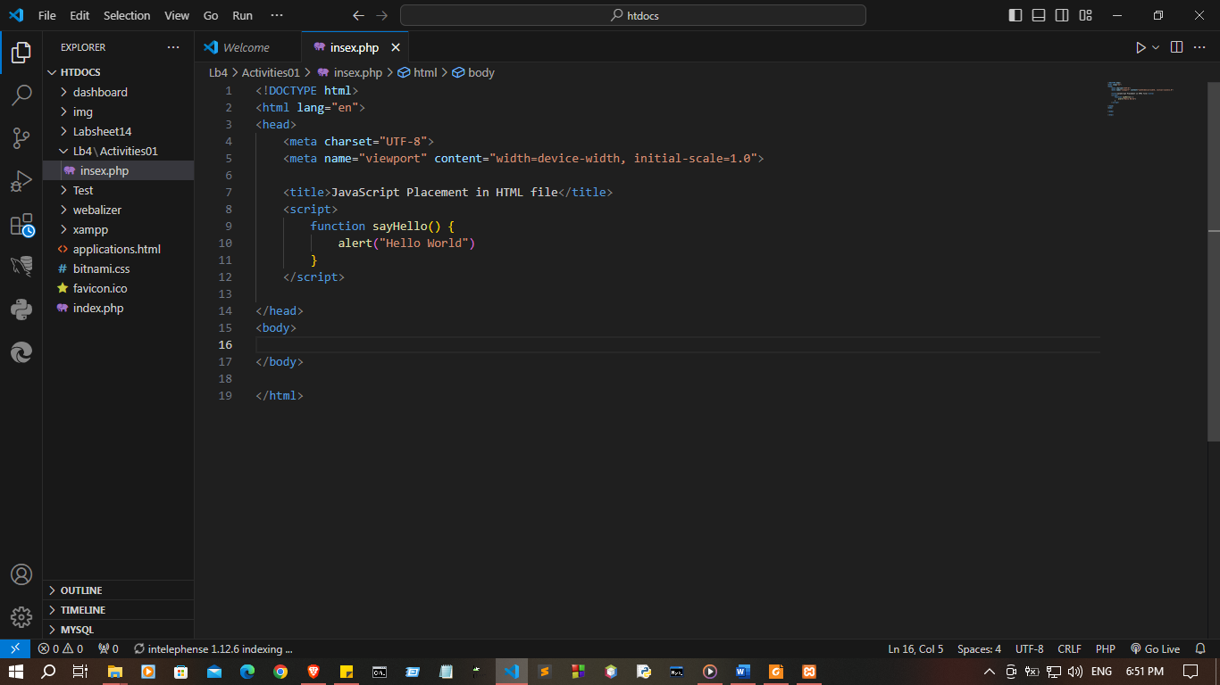
II. Script in <body> section

<body>
<input type = "button" onclick = "sayHello()" value = "Say Hello" />
<script>
function sayHello() {
alert("Hello World")
}
</script>
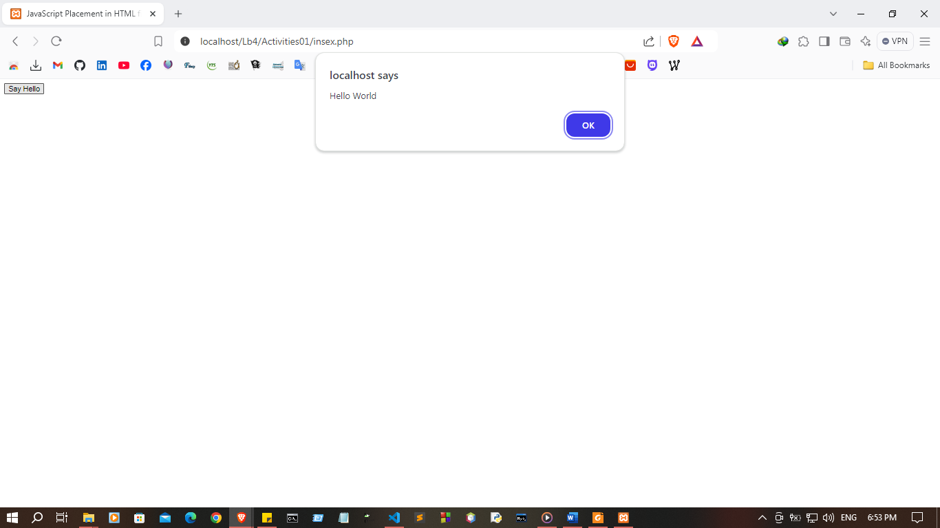
</body>

III. Script in an external file

// script.js

function sayHello() {
console.log("Hello World")
}

< !-- index.php -->
<!DOCTYPE html>
<html lang="en"> <head>
<title>JavaScript Placement in HTML file</title>
<script src = "script.js" ></script>
</head>
<body>
<input type = "button" onclick = "sayHello()" value = "Say Hello" />
</body>
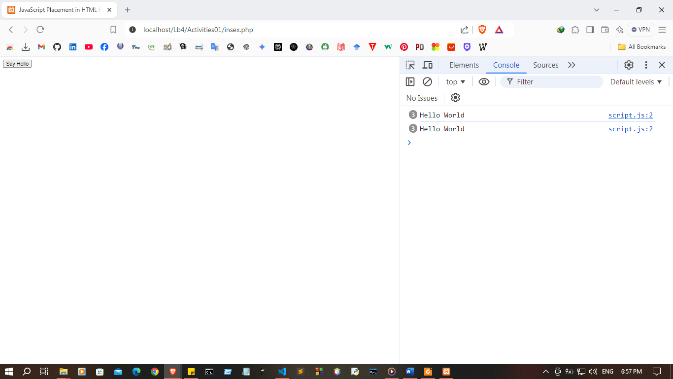
</html>

- Variables & Data Types

- Variables

<script>
// Without using any keywords.
// Using the 'var' keyword.
// Using the 'let' keyword.
// Using the 'const' keyword.
var name;
marks;
_age;
var gpa = 3.4;
let reg_no = "ICT000";
const DEP = "Faculty of Technology";
</script>

<!DOCTYPE html>
<html lang="en">
<head>
<meta charset="UTF-8">
<meta name="viewport" content="width=device-width, initial-scale=1.0">
<title>Document</title>
<script>
// Without using any keywords (marks and _age).
marks = 85;
_age = 24;

// Using the 'var' keyword.
var name = "Kalhara";
var gpa = 4.0;

// Using the 'let' keyword.
let reg_no = "SEU/IS/20/ICT/084";

// Using the 'const' keyword.
const DEP = "Faculty of Technology";

// Output to the console
console.log("Name (var): " + name);
console.log("Marks (no keyword): " + marks);
console.log("Age (no keyword): " + _age);
console.log("GPA (var): " + gpa);
console.log("Registration Number (let): " + reg_no);
console.log("Department (const): " + DEP);
</script>
</head>
<body>
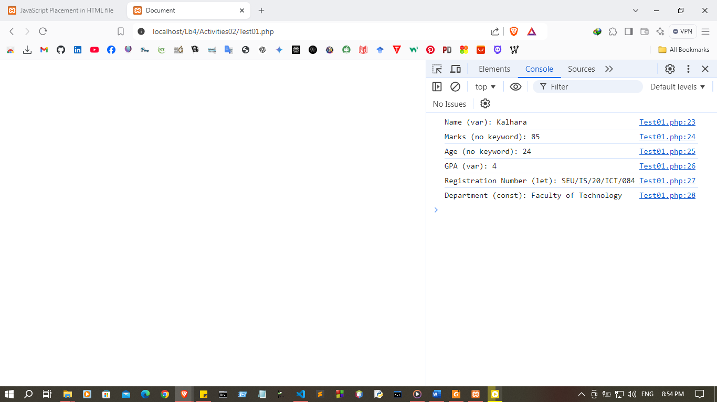

II. Data Types
<script>
// String
var str1 = "Hello";
// Integer
var num1 = 45;
// Floating point number
var float1 = 78.45;
// Boolean
var bool1 = true;
// Undefined
let udef1 = undefined;
// Null
let var1 = null;
// Object
const obj = {
animal: "Hourse", legs: 4, hourseColor: "Brown"
}

//Array
const colors = ["Brown", "red", "pink", "Yellow", "Blue"];
// Date
let date = new Date();

</script>

<!DOCTYPE html>
<html lang="en">
<head>
<meta charset="UTF-8">
<meta name="viewport" content="width=device-width, initial-scale=1.0">
<title>Document</title>
<script>
// String
var str1 = "Hello Kalhara";
// Integer
var num1 = 85;
// Floating point number
var float1 = 78.45;
// Boolean
var bool1 = true;
// Undefined
let udef1 = undefined;
// Null
let var1 = null;
// Object
const obj = {
animal: "Horse", legs: 4, hourseColor: "Brown"
}
// Array
const colors = ["Brown", "red", "pink", "Yellow", "Blue"];
// Date
let date = new Date();

// Output all variables to the console
console.log("String: " + str1);
console.log("Integer: " + num1);
console.log("Floating point number: " + float1);
console.log("Boolean: " + bool1);
console.log("Undefined: " + udef1);
console.log("Null: " + var1);
console.log("Object: ", obj);
console.log("Array: ", colors);
console.log("Date: ", date);
</script>

</head>
<body>
</body>
</html>

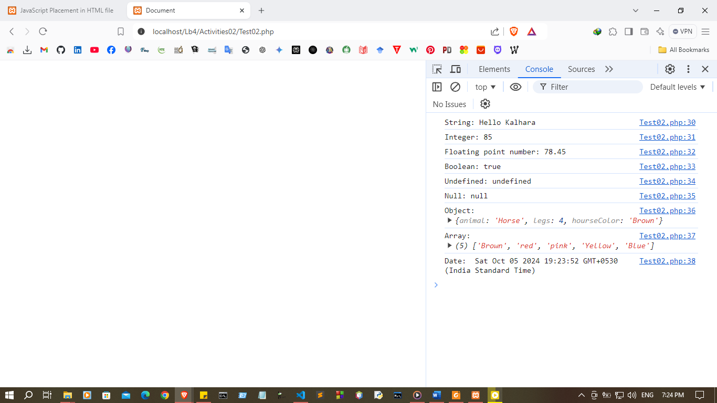

3. Object and functions
I. Function

// script.js
// function name(parameter1, parameter2, parameter3) {
// code to be executed
// }
function addition(number1, number2) {
return number1 + number2;
}

< p id="cal_function"></p>
<script>
let sum = addition(5,6);
document.getElementById("cal_function").innerHTML = sum;
</script>

Index.php
<!DOCTYPE html>
<html lang="en">
<head>
<meta charset="UTF-8">
<meta name="viewport" content="width=device-width, initial-scale=1.0">
<title>Document</title>
<script src = "script.js" ></script>
</head>
<body>

<p id="cal_function"></p>
<script>
let sum = addition(10,10);
document.getElementById("cal_function").innerHTML = sum;
</script>

</body>
</html>

script.js
function addition(number1, number2) {
return number1 + number2;
}
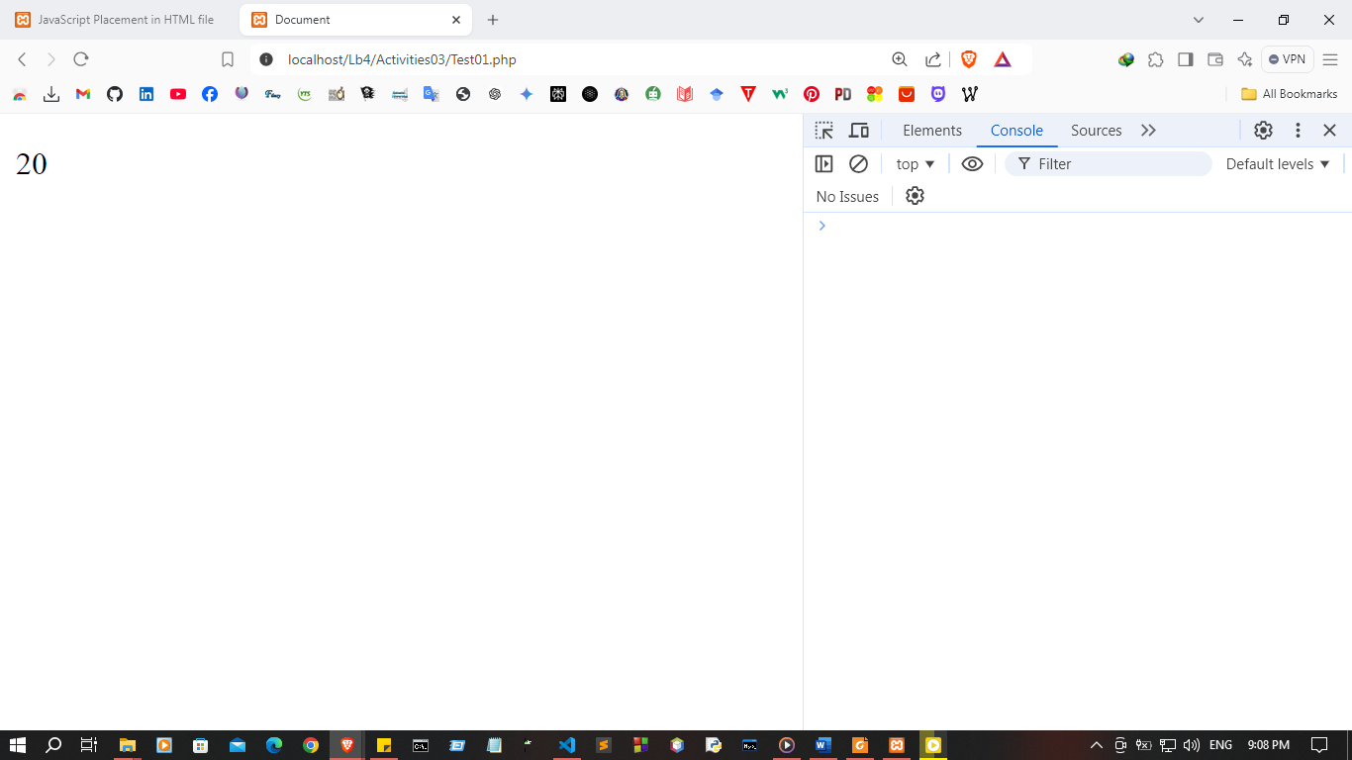

II. Object
// Creating Object
const house = { address: "Main street, B City", bedrooms: 4, bathroom: 2 };
// Create empty object and add properties
const house2 = {};
house2.address = "Main street, B City";
house2.bedrooms = 4; house2.bathroom = 2;
// Create object with new keyword
const house3 = new Object();
house3.address = "Main street, B City";
house3.bedrooms = 4;
house3.bathroom = 2;
<!DOCTYPE html>
<html lang="en">
<head>
<meta charset="UTF-8">
<meta name="viewport" content="width=device-width, initial-scale=1.0">
<title>Document</title>
<script>
// Creating Object
const house = {
address: "Main street, B City",
bedrooms: 4,
bathroom: 2
};

// Create empty object and add properties
const house2 = {};
house2.address = "Main street, B City";
house2.bedrooms = 4;
house2.bathroom = 2;

// Create object with new keyword
const house3 = new Object();
house3.address = "Main street, B City";
house3.bedrooms = 4;
house3.bathroom = 2;

// Output all objects to the console
console.log("House 1:", house);
console.log("House 2:", house2);
console.log("House 3:", house3);
</script>
</head>
<body>

</body>
</html>

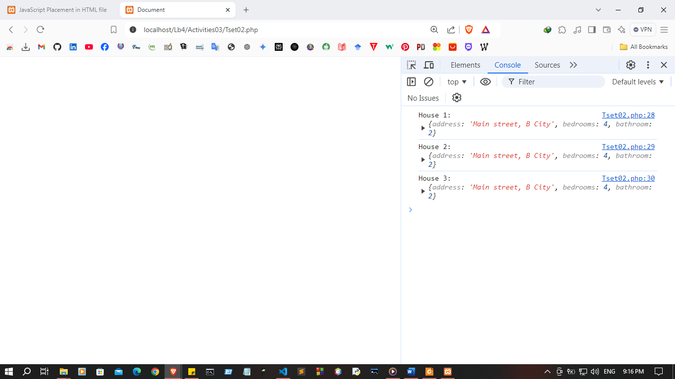
III. Object Method

const house = { address: "Main street, B City", bedrooms: 4, bathroom: 2, getAddress:
function () {
return this.address;
}
};

<h5>Address : </h5>
<p id="address"></p>
<script>
let address = house.getAddress();
document.getElementById("address").innerHTML = address;
</script>

<!DOCTYPE html>
<html lang="en">
<head>
<meta charset="UTF-8">
<meta name="viewport" content="width=device-width, initial-scale=1.0">
<title>Display House Address</title>
</head>
<body>
<h5>Address :</h5>
<p id="address"></p>

<script>
const house = {
address: "Main street, B City",
bedrooms: 4,
bathroom: 2,
getAddress: function() {
return this.address;
}
};
let address = house.getAddress();
document.getElementById("address").innerHTML = address;
</script>
</body>
</html>
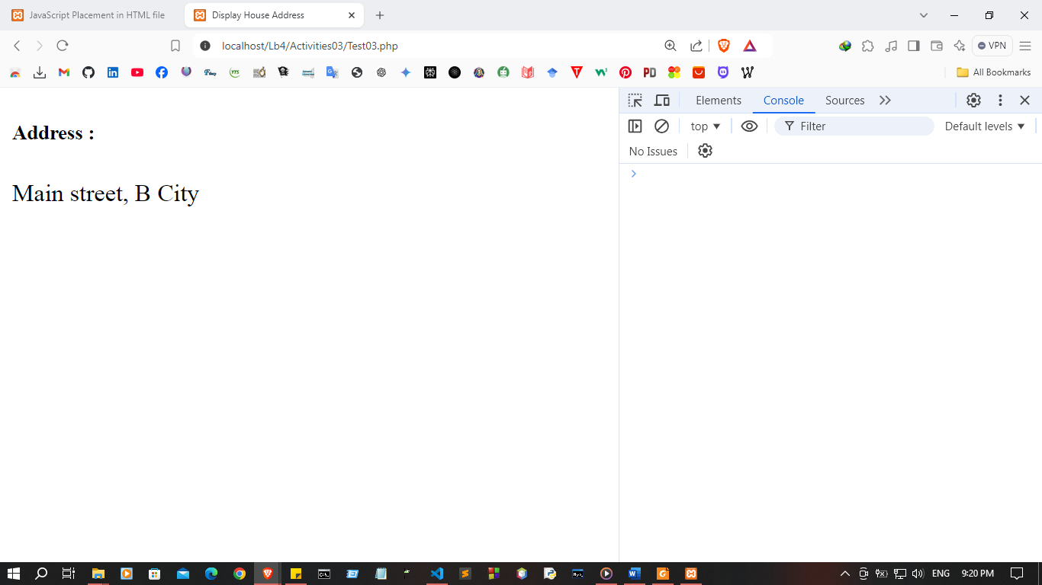

IV. Object Constructor
function Person(first_name, last_name, age) {
this.first_name = first_name;
this.last_name = last_name;
this.age = age;
this.getFullName = function() {
return `${this.first_name} ${this.last_name}`;
};
}

<h5>Person : </h5>
<p id="person"></p>
<script>
let person1 = new Person("Oliver","George", 30);
document.getElementById("person").innerHTML =
person1.getFullName();
</script>

<!DOCTYPE html>
<html lang="en">
<head>
<meta charset="UTF-8">
<meta name="viewport" content="width=device-width, initial-scale=1.0">
<title>Person Example</title>
</head>
<body>
<h5>Full Name :</h5>
<p id="full-name"></p>

<script>
function Person(first_name, last_name, age) {
this.first_name = first_name;
this.last_name = last_name;
this.age = age;
this.getFullName = function() {
return `${this.first_name} ${this.last_name}`;
};
}
const person1 = new Person("Pasan", "Kalhara", 24);
let fullName = person1.getFullName();
document.getElementById("full-name").innerHTML = fullName;
</script>
</body>
</html>
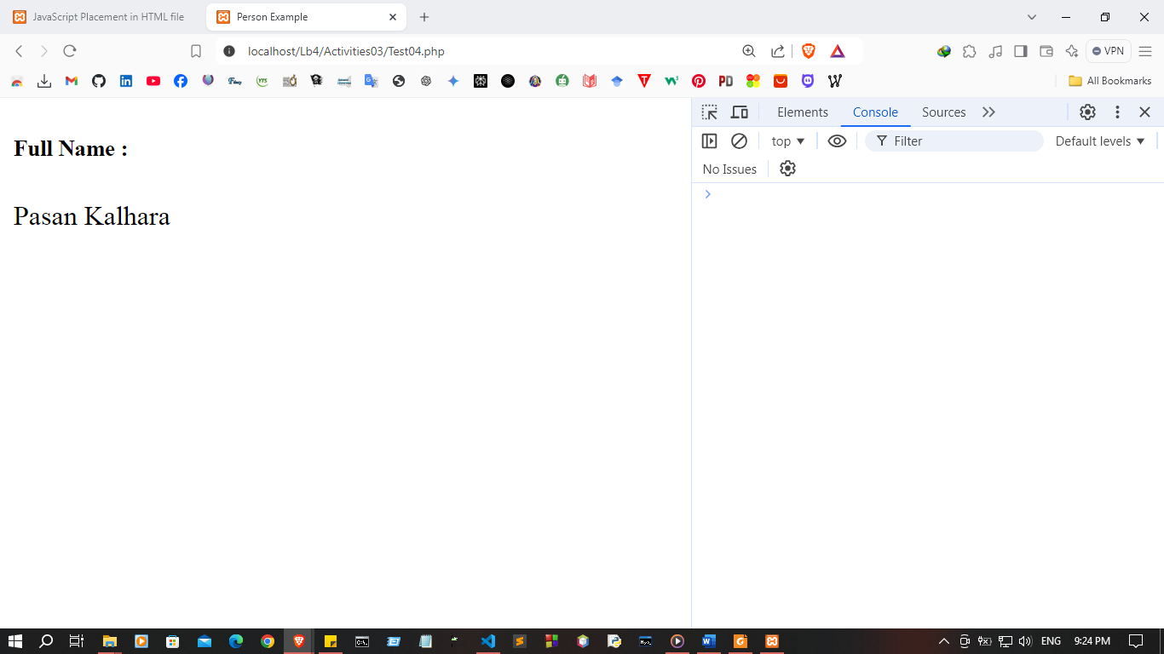

- Event handling

function handleSelectChange() {
const selectElement = document.getElementById("mySelect");
const selectedValue = selectElement.value;
document.getElementById("selectedValue").textContent = `You selected:
${selectedValue}`;
}
<select id="mySelect" onchange="handleSelectChange()">
<option value="Apple">Apple</option>
<option value="Orange">Orange</option>
<option value="Mango">Mango</option> </select>
<p id="selectedValue"></p>

<!DOCTYPE html>
<html lang="en">
<head>
<meta charset="UTF-8">
<meta name="viewport" content="width=device-width, initial-scale=1.0">
<title>Select Dropdown Example</title>
</head>
<body>

<h5>Select a Fruit:</h5>
<select id="mySelect" onchange="handleSelectChange()">
<option value="Apple">Apple</option>
<option value="Orange">Orange</option>
<option value="Mango">Mango</option>
</select>
<p id="selectedValue"></p>

<script>
function handleSelectChange() {
const selectElement = document.getElementById("mySelect");
const selectedValue = selectElement.value;
document.getElementById("selectedValue").textContent = `You selected: ${selectedValue}`;
}
</script>

</body>
</html>
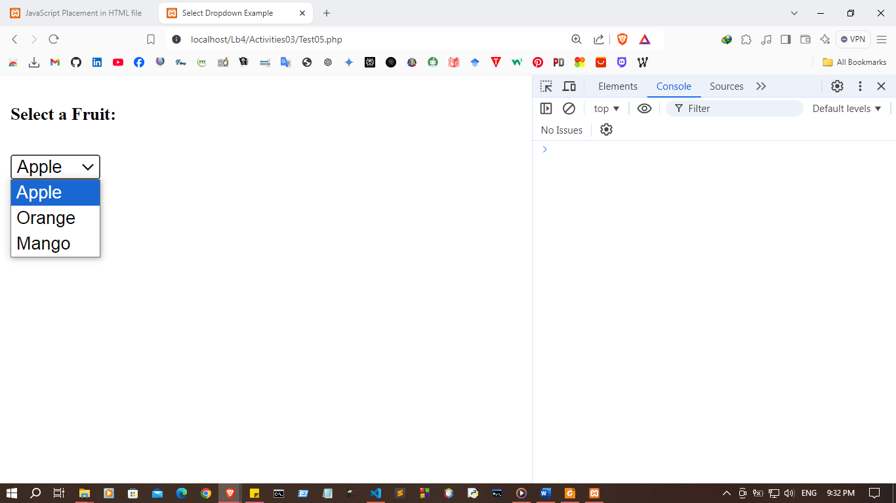

Event Name | Description
onchange | Fires when the value of an element changes
onclick | Triggers when the user click on an element
onmouseover | Occurs when the mouse moves over an  element
onmouseout | Fires when the mouse moves away from an  element
onkeydown | Triggers when the user presses a key down
onload | Fires when the entire web page finishes  loading

<!DOCTYPE html>
<html lang="en">
<head>
<meta charset="UTF-8">
<meta name="viewport" content="width=device-width, initial-scale=1.0">
<title>Event Example</title>
</head>
<body onload="alert('Page loaded!')">

<h3>Interactive Elements</h3>

<!-- onchange -->
<select onchange="alert('Selection changed!')">
<option value="apple">Apple</option>
<option value="banana">Banana</option>
</select>

<br><br>

<!-- onclick -->
<button onclick="alert('Button clicked!')">Click Me</button>

<br><br>

<!-- onmouseover & onmouseout -->
<div
onmouseover="this.style.backgroundColor='lightblue'"
onmouseout="this.style.backgroundColor=''"
style="padding:10px; width:150px; border:1px solid black;">
Hover over me!
</div>

<br><br>

<!-- onkeydown -->
<input type="text" onkeydown="alert('Key pressed!')" placeholder="Type something">

</body>
</html>
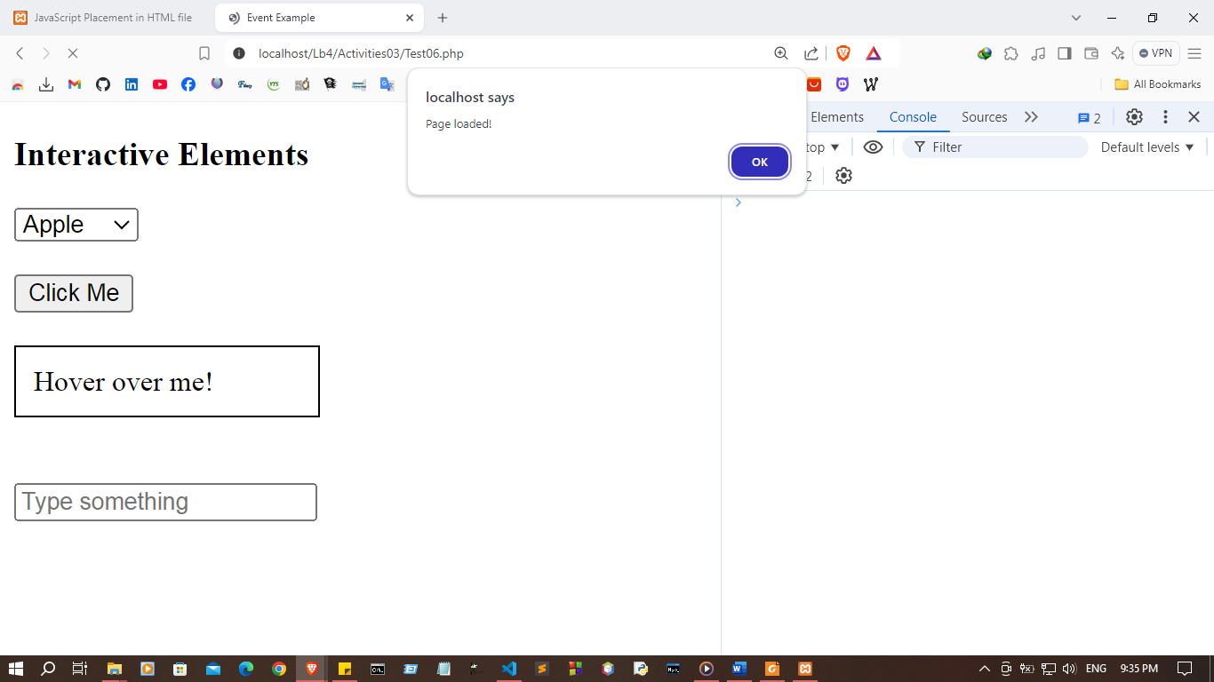

Discussion:

- In this lab session, I explored various fundamental aspects of JavaScript. One of the key goals was understanding how to run JavaScript in different ways, such as embedding it within HTML files or linking it externally. I gained insights into JavaScript's variable declaration and the diverse data types, like strings, numbers, booleans, and more. The session also introduced me to objects and functions, emphasizing their essential role in structuring JavaScript code and enabling reusability. Additionally, I explored event handling, which is crucial for making web pages interactive by responding to user actions like clicks or key presses. This hands-on experience provided a solid foundation for writing more dynamic and responsive web applications.

